**Summer Project Report on**

**“STARKONNECT”**

**By**

**Group No:5**

Pratik Bhosale (5019106)

Mikhael Uzagare (5019139)

Madhur Thakkar (5019156)

Sam Thomas (5019164)



**Department of Information Technology**

**Fr. Conceicao Rodrigues Institute of Technology**

Sector 9A, Vashi, Navi Mumbai – 400703

University of Mumbai

2021-2022

**Abstract**

In this competitive era, the education among the people is so increasing that the jobs for them are now decreasing. The start-ups even want the people who are best in their fields. It becomes difficult to find the people who are intelligent enough to be hired. The work for the start-ups also increases to find the people who can fulfill their requirements. Thinking about these problems, one can think about the process which can handle this process and make the work less complex.

Job Portal is the solution where recruiter as well as the job seeker meet aiming at fulfilling their individual requirement. Therefore, we have developed an interactive website to connect start-ups with freelancers.

The following modules would be implemented:

1. Login/Sign Up
2. Profile page.
3. Jobs:

* Jobs Applied
* Create a job
* Jobs posted

The Graphical User Interface (GUI) would be simple and user-friendly.

We aim to do our bit by facilitating a user-friendly website that will help start-ups by saving time and resources for hiring freelancers.

I

**TABLE OF CONTENTS**

|  |  |  |  |  |  |
| --- | --- | --- | --- | --- | --- |
| **Sr. No.** |  | | **Topic** | **Page No.** |  |
|  |  | | |  |  |
|  | Introduction | | |  |  |
|  | 1.1 | Background | |  |  |
| 1 | 1.2 | Motivation/ need/ purpose | | 1 |  |
| 1.3 | Problem Definition | |  |
|  |  |  |
|  | 1.4 | Scope | |  |  |
|  | 1.5 | Proposed System Features | |  |  |
|  | 1.6 | Objectives | |  |  |
|  | 1.7 | Issues /Limitations | |  |  |
|  |  | | |  |  |
| 2 | Literature Survey  2.1 Existing System | | | 4 |  |
|  |  | | |  |  |
| 3 | System Design  3.1 Architecture Diagram | | | 7 |  |
|  |  | | |  |  |
|  | System Requirement | | |  |  |
| 4 | 4.1 Hardware | | | 8 |  |
|  | 4.2 Software | | |  |  |
|  |  | |  |  |  |

II

|  |  |  |  |  |
| --- | --- | --- | --- | --- |
| **Sr. No.** |  | **Topic** | **Page No.** |  |
|  |  | |  |  |
| 5 | Implementation Details   * 1. User Interface   5.2 Database Details | | 9 |  |
|  |  | |  |  |
| 6 | Experimental Results | | 19 |  |
|  |  | |  |  |
| 7 | Conclusion/Future Scope  7.1Conclusion    7.2Future Scope | | 20 |  |
|  |  | |  |  |
| 8 | Appendix: Code Sample | | 21 |  |
|  |  | |  |  |
|  | References | | 30 |  |
| 9 |  | |  |  |
| 10 | Acknowledgement | | 31 |  |
|  |  |  |  |  |

III

**LIST OF FIGURES**

|  |  |  |
| --- | --- | --- |
| **Fig. No.** | **Figure Name** | **Page No.** |
| Fig 3.1 | Architectural Design | 7 |
| Fig 5.1 | Sign-up Page | 9 |
| Fig 5.2 | Login Page | 9 |
|  |  |  |
| Fig 5.3 | OTP Verification | 10 |
|  |  |  |
| Fig 5.4 | Select Account Type | 10 |
| Fig 5.5 | Freelancer Home Page | 11 |
| Fig 5.6 | Start-up Home Page | 11 |
| Fig 5.7 | Freelancer Successfully Applied to an opening | 12 |
| Fig 5.8 | Freelancer My Applications Page | 12 |
| Fig 5.9 | Freelancer Profile Creation | 13 |
| Fig 5.10 | Freelancer Profile Page | 13 |
| Fig 5.11 | Start-up Profile Creation | 14 |
| Fig 5.12 | Start-up Profile Page | 14 |
| Fig 5.13 | Start-up Create Job Page | 14 |
| Fig 5.14 | Start-up Posted Jobs Page | 15 |
| Fig 5.21 | Database Structure | 15 |
| Fig 5.22 | users table | 16 |
| Fig 5.23 | usersprofiles table | 16 |
| Fig 5.24 | startup_profiles table | 17 |
| Fig 5.25 | jobs_posted table | 17 |
| Fig 5.26 | jobs_applied table | 18 |

**LIST OF TABLES**

|  |  |  |
| --- | --- | --- |
| **Table. No.** | **Table Name** | **Page No.** |
|  |  |  |
| Table 1 | Existing Systems | 6 |

IV

**CHAPTER 1**

**INTRODUCTION**

**1. INTRODUCTION**

**1.1 BACKGROUND**

The importance of placement system is increasing day by day. Thousands of applicants are dependent upon the traditional placement system. But the applicants are facing so many problems. This project is an attempt to minimize the problems of an applicant to find a correct job. If we can make it an online computerized and a mobile alert process it will be so fast and convenient for the applicants. Far from upsetting matters, however, new technologies have predominantly made life better and considerably easier for most people, and so it must be concluded that they should be welcomed. Software does not require a dedicated computer and can be run on almost any PC running Windows.

* 1. **MOTIVATION / NEED / PURPOSE**

The purpose of developing an Online Job Search Portal comes from the idea to make the job search efficient and handy. It helps the recruiters as a primary source of talent search. It also helps the job seekers to search for current vacancies at a single point. Therefore, we can say that Online Job Search Portal act as a bridge of communication between organizations and applicants. With the evolution of technology and internet being the main source of information for the applicants, these job portals and have become an excellent method to reach wide range of audience.

**1**

* 1. **PROBLEM DEFINITION**

To design a user-friendly website to simplify the hiring process for Startups and Freelancers.

* 1. **SCOPE**
* In this competitive era, the education among the people is so increasing that the jobs for them are now decreasing.
* The start-ups even want the people who are best in their fields.
* Our website will provide two profile types, freelancer and start-ups.
* It will simplify the hiring process for start-ups and provide increased opportunities for freelancers.
  1. **PROPOSED SYSTEM FEATURES**

Most of the job portals lists all the major companies in all major domains, what this does is these being big companies attract more students/freelancers but they hire negligible number of candidates and due to the presence of such big companies, small and emerging start-ups often get neglected by users. Therefore, we have designed a website specifically for start-ups and freelancers.

Our website provides two profile options freelancers and startups. Startups can create their profile page and view their profile at ‘My profile’ and they can post job openings through the ‘Create jobs’ tab. Start-ups can also view the jobs they have posted and the freelancers who have applied for the jobs through from the ‘Jobs Posted’ tab. Freelancers can also create their profile page and can view their profile at ‘My profile’ and can also apply for the job

**2**

openings posted by the startups through their homepage where the jobs of requirements of various start-ups will be listed. The applied jobs can be viewed through ‘My Applications’ tab. The website has simple and easy to use user interface

* 1. **OBJECTIVES**

1. To connect Startups and Freelancers.
2. Simplify internship Recruitment process.
3. To help Startups grow by providing them exposure.
4. To help freelancers keep track of positions they have applied to.

**1.7 ISSUES/LIMITATIONS**

1. Designed specifically for startups and freelancers.
2. No feature for messaging.
3. No feature for posting articles, videos, success stories.
4. Password is not Encrypted.
5. Data is not Validated.

**3**

**CHAPTER 2**

**LITERATURE SURVEY**

**2. LITERATURE SURVEY**

**2.1 EXISTING SYSTEM**

**[1] LinkedIn**

LinkedIn is the world's largest professional network on the internet. You can use LinkedIn to find the right job or internship, connect and strengthen professional relationships, and learn the skills you need to succeed in your career. You can access LinkedIn from a desktop, LinkedIn mobile app, mobile web experience, or the LinkedIn Lite Android mobile app.

A complete LinkedIn profile can help you connect with opportunities by showcasing your unique professional story through experience, skills, and education. You can also use LinkedIn to organize offline events, join groups, write articles, post photos and videos, and more. But LinkedIn can lead to a large number of spam messages and professional accounts are costly.

**[2] Internshala**

Internshala is a dot com business with the heart of dot org. It is a technology company on a mission to equip students with relevant skills & practical exposure through internships and online trainings. Internshala boasts a simple yet interactive User Interface which makes the task even easier.

They also provide various features like resume-builder and online trainings for applicants on various topics. The main thing about this website is that it lists a lot of startups providing stipend and non-stipend internship offers of all fields.

**4**

**[3] MonsterIndia**

Monster India is India’s leading online career and recruitment resource with its cutting-edge technology provides relevant profiles to employers and relevant jobs to jobseekers across industry verticals, experience levels and geographies.

Monster provides the widest and most sophisticated job seeking, career management, recruitment and talent management capabilities globally.

**5**



**Table 1. Summary of the existing systems**

**6**

**CHAPTER 3**

**SYSTEM DESIGN**

**3 SYSTEM DESIGN**

* 1. **ARCHITECTURE DESIGN**

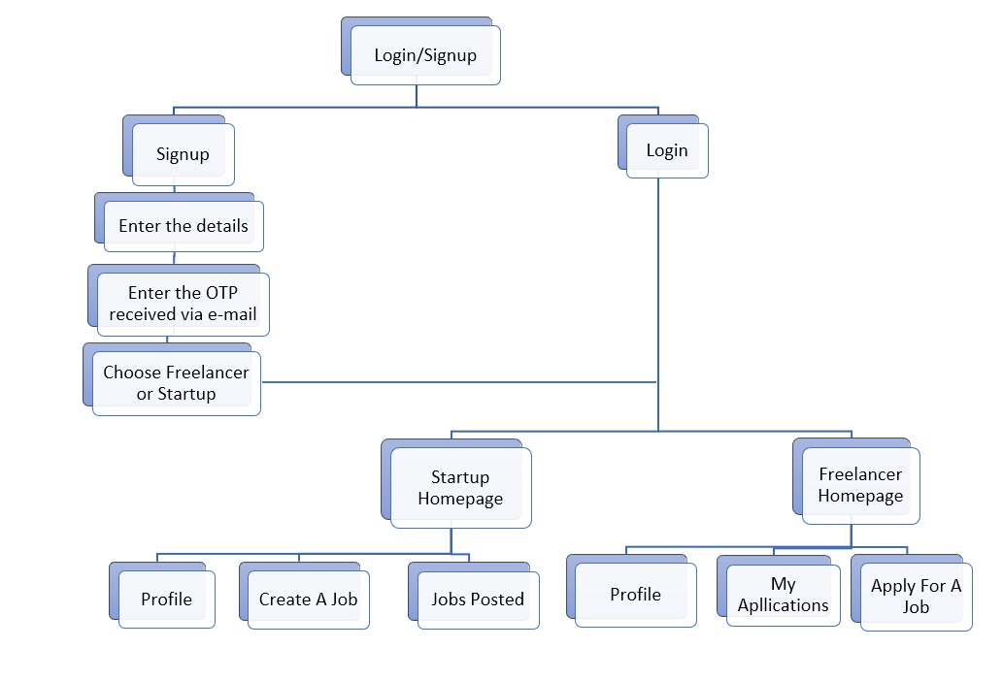

**7**

**CHAPTER 4**

**SYSTEM REQUIREMENTS**

13

**4. SYSTEM REQUIREMENTS**

**4.1 HARDWARE**

* Memory: 4GB RAM or higher
* Graphics: 2GB
* Processor: i5 or higher
* Hard Disk Space: 500GB or higher

**4.2 SOFTWARE (For User)**

* Any compatible web browser (eg: Edge, Chrome, etc.)

**4.3** **SOFTWARE (For Development)**

* Spyder for python-flask
* Atom for html, CSS, JavaScript
* Web browser

**8**

13

**CHAPTER 5**

**IMPLEMENTATION DETAILS**

**5. IMPLEMENTATION DETAILS**

**5.1 USER INTERFACE**

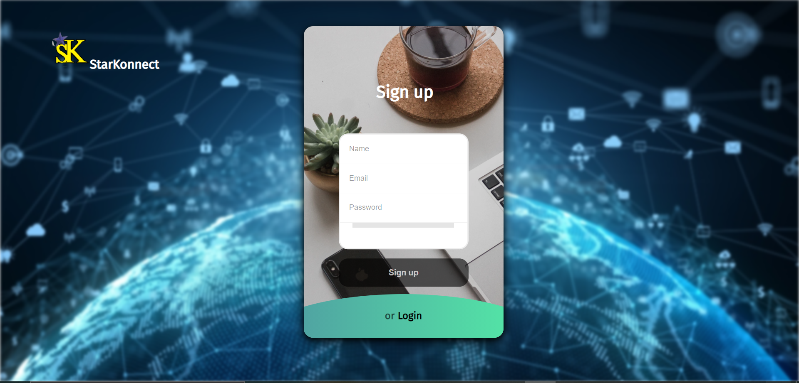

**Fig 5.1 Sign up page**

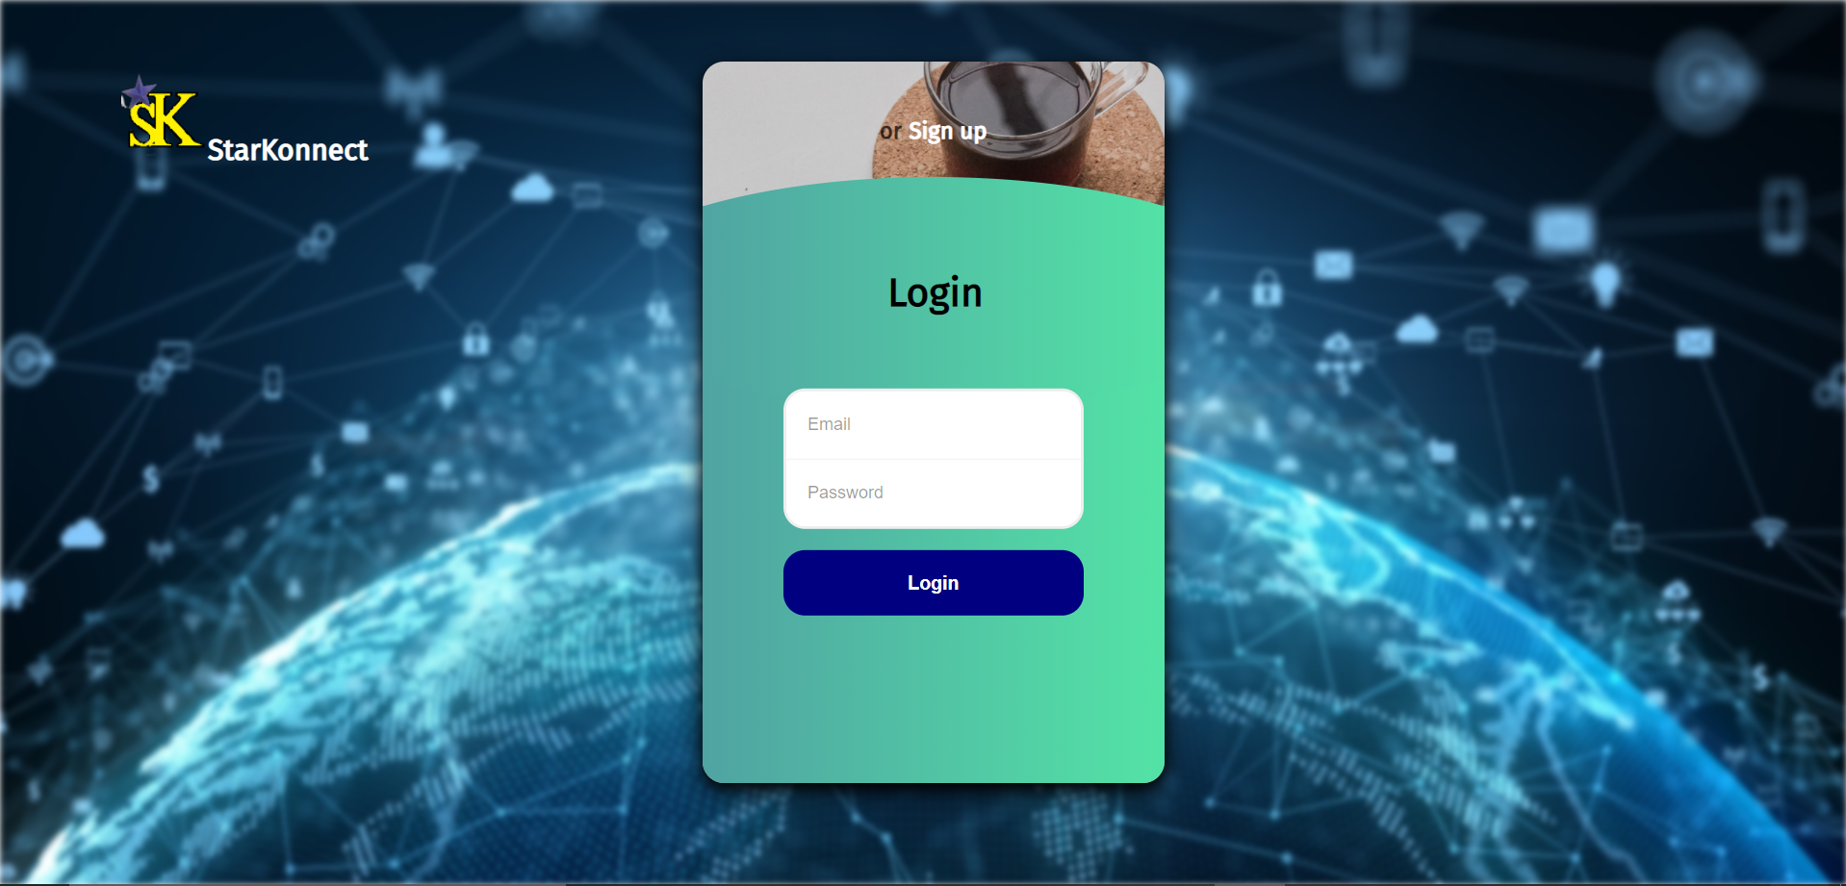

**Fig 5.2 User Login page**

**9**

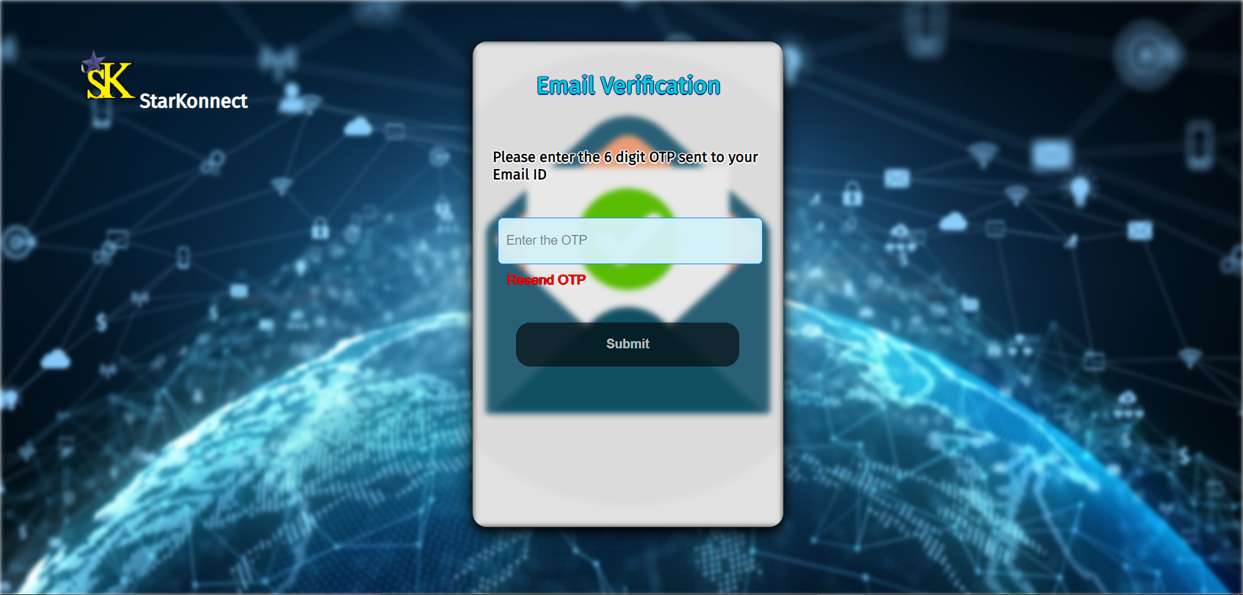

**Fig 5.3 OTP Verification page**

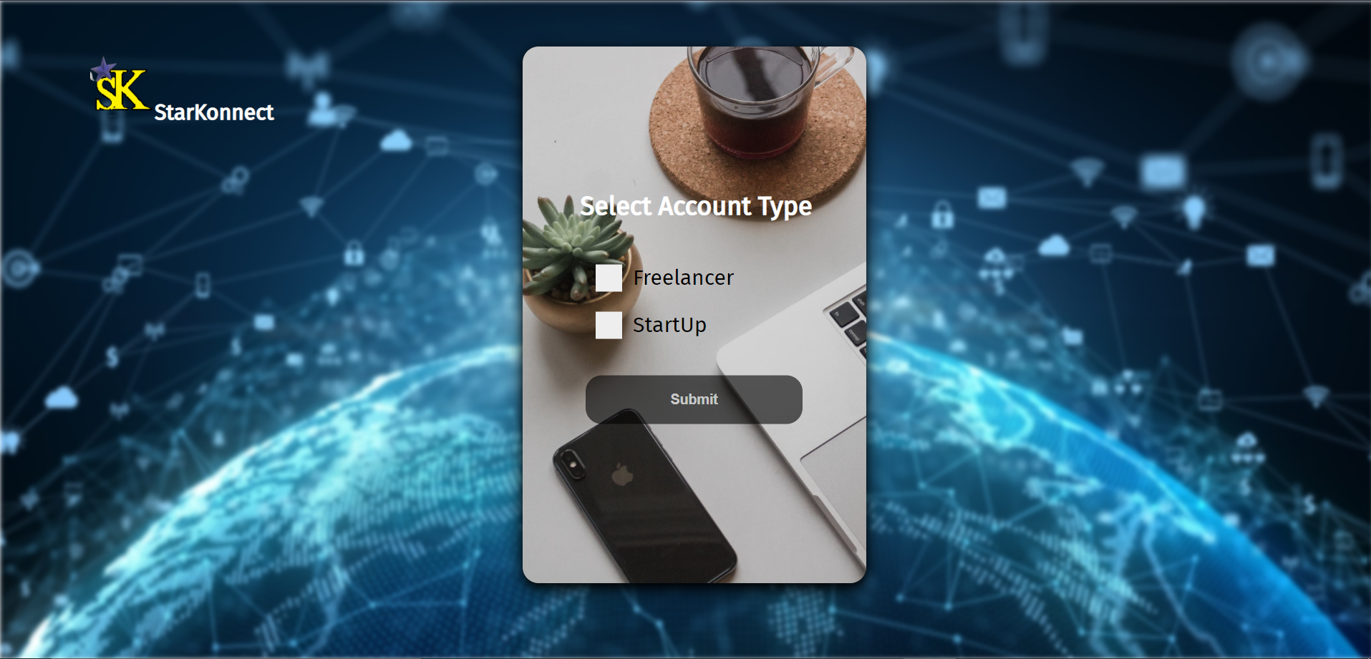

**Fig 5.4 Select Account Type**

**10**

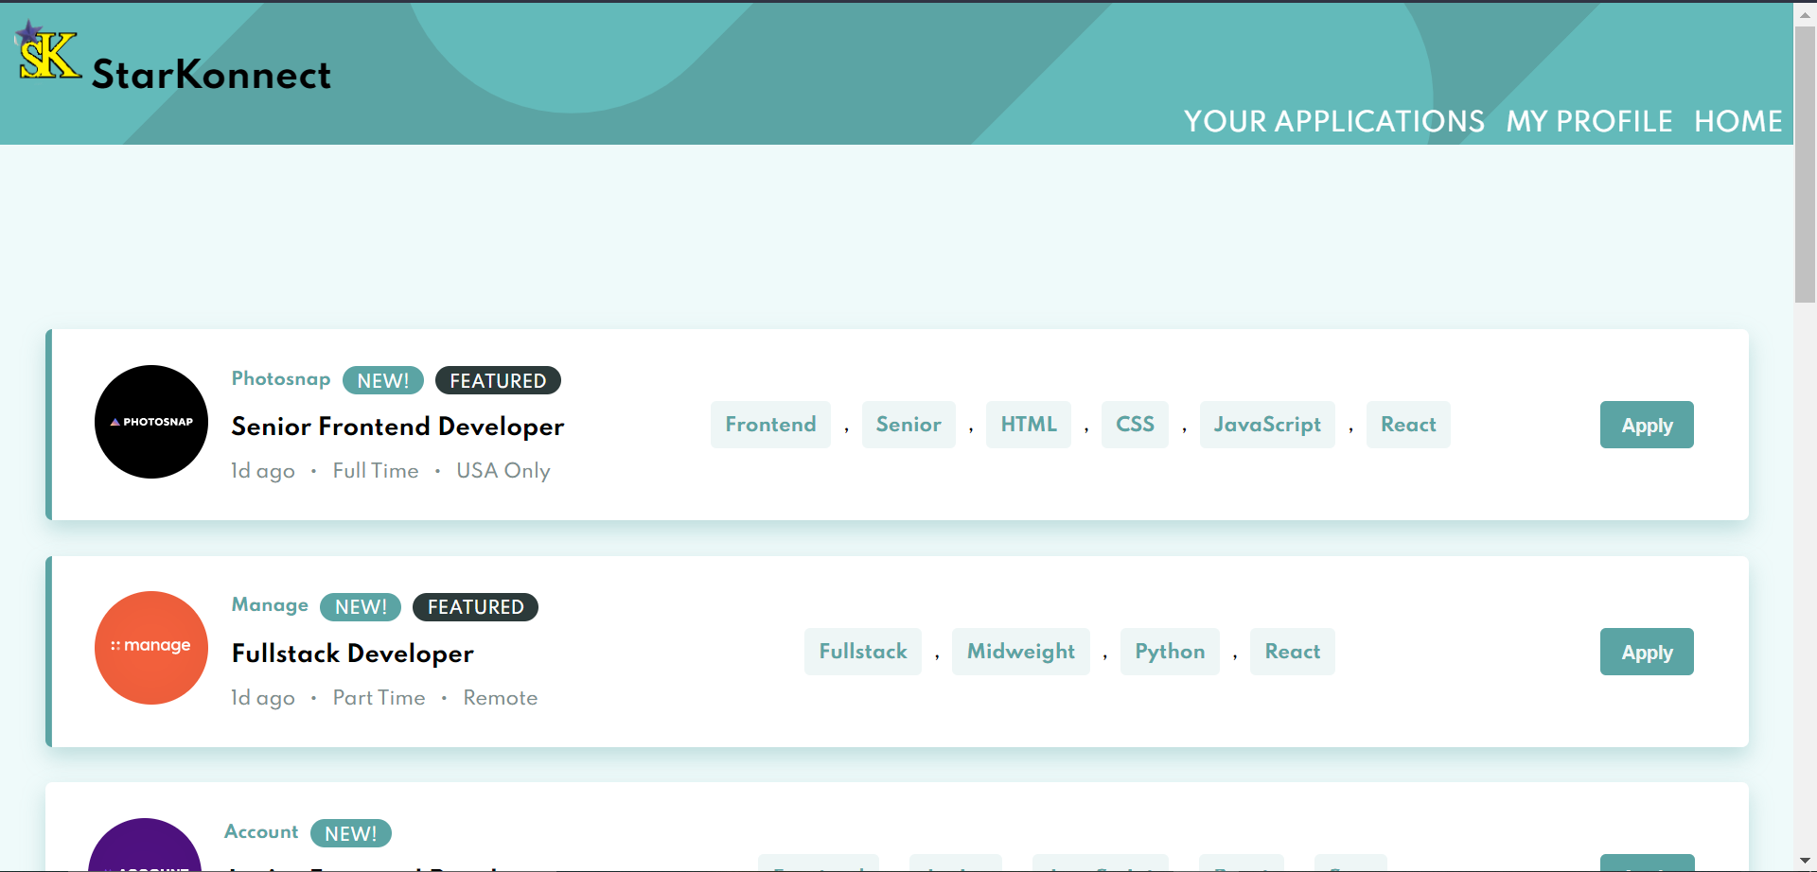

**Fig 5.5 Freelancer Home Page**

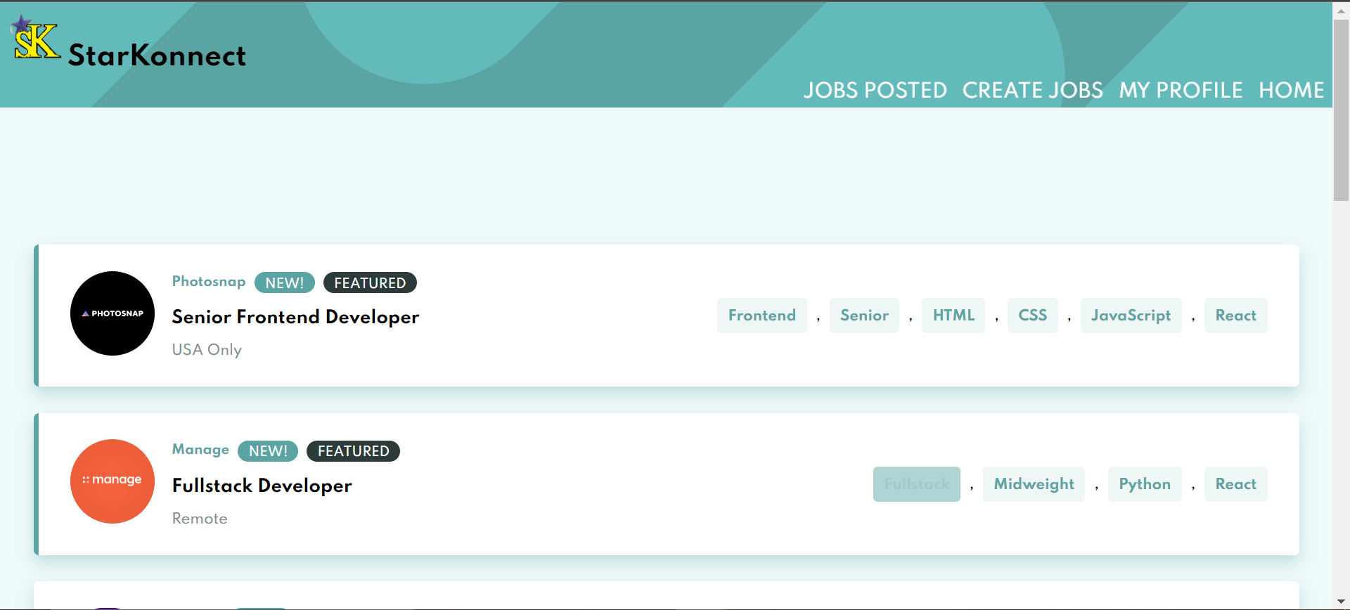

**Fig 5.6 Start-up Home Page**

**11**

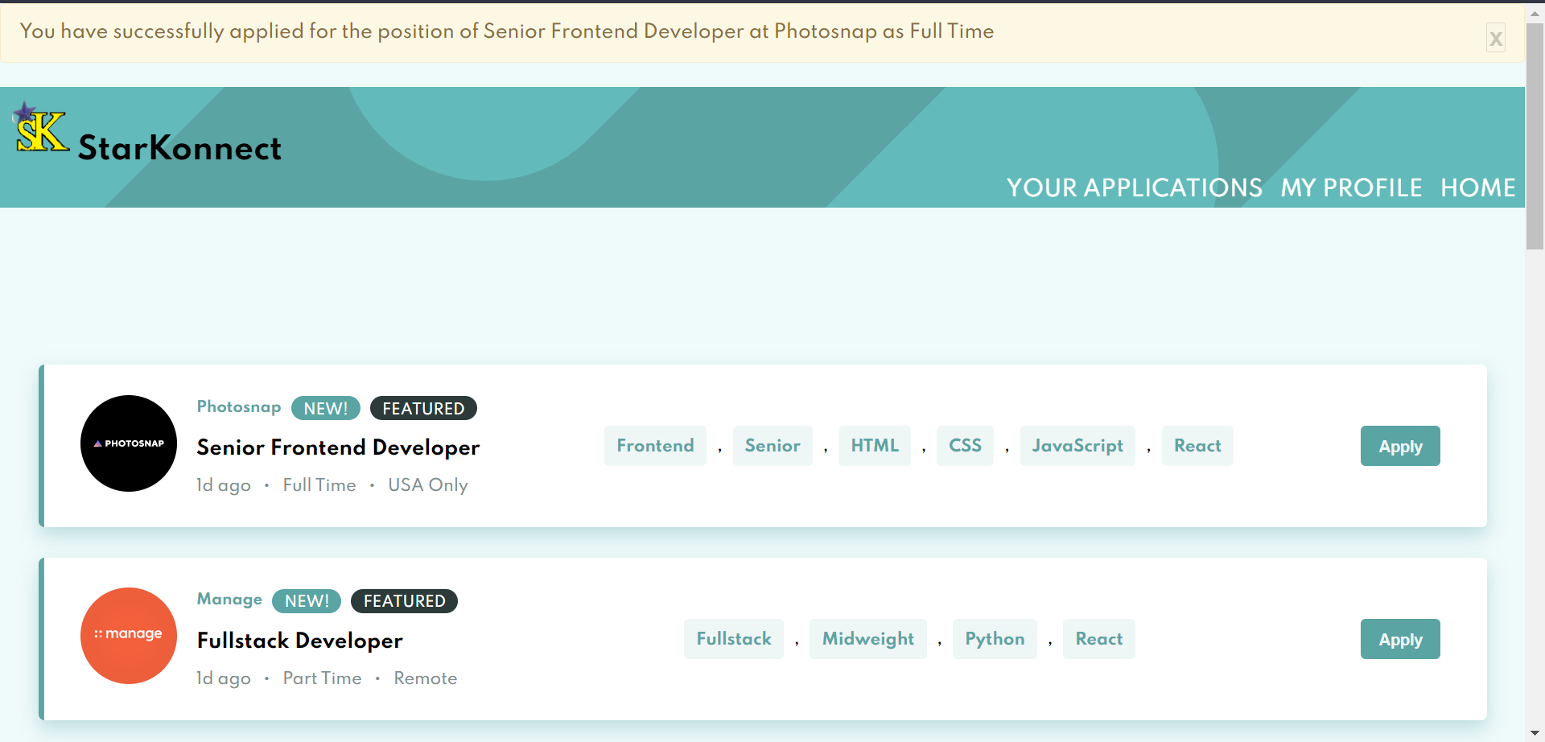

**Fig 5.7 Freelancer Successfully Applied to an opening**

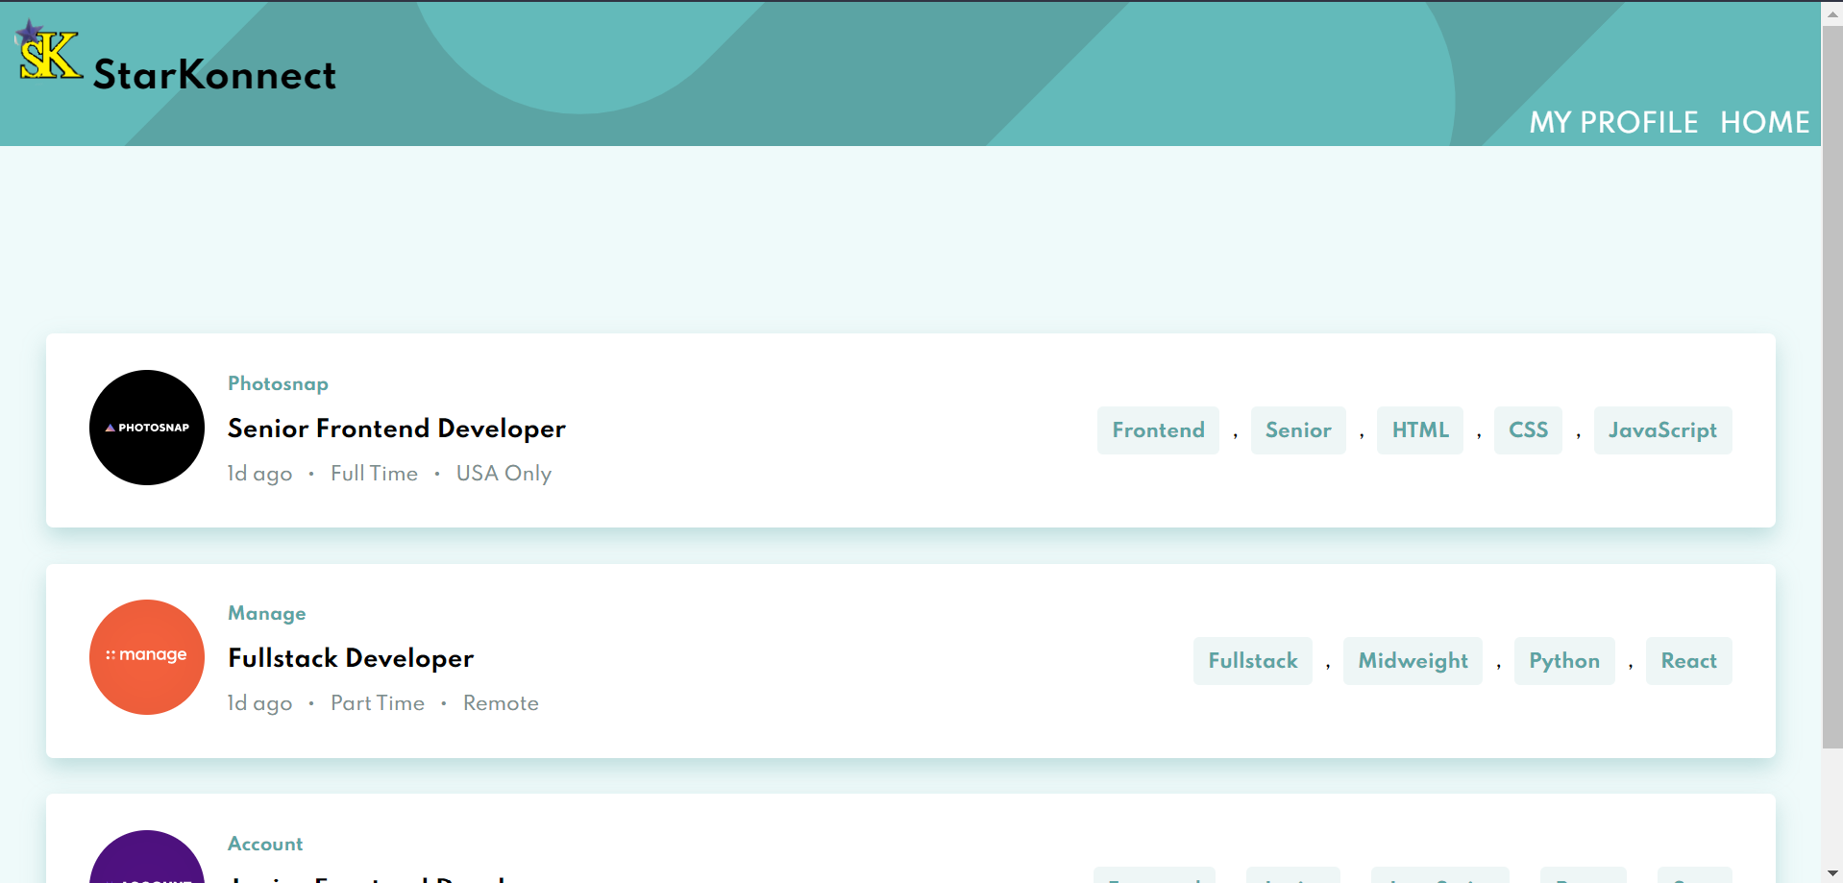

**Fig 5.8 Freelancer My Applications Page - Listing all openings they have applied to.**

**12**

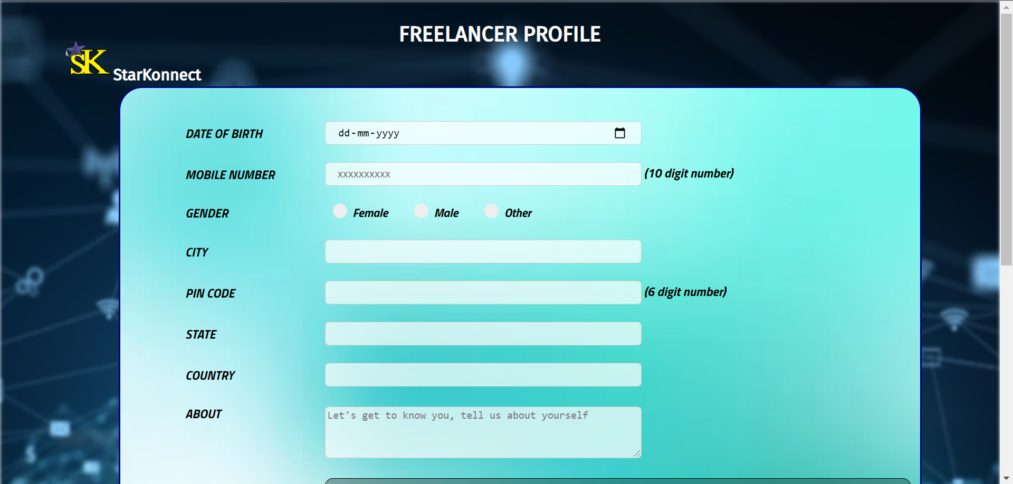

**Fig 5.9 Freelancer Profile Creation**

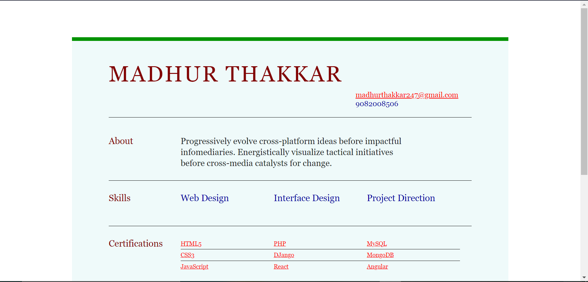

**Fig 5.10 Freelancer Profile Page**

**13**

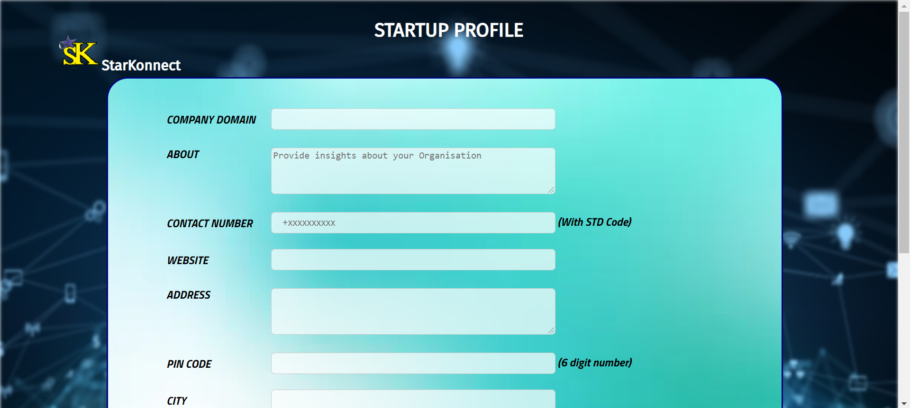

**Fig 5.11 Start-up Profile Creation**

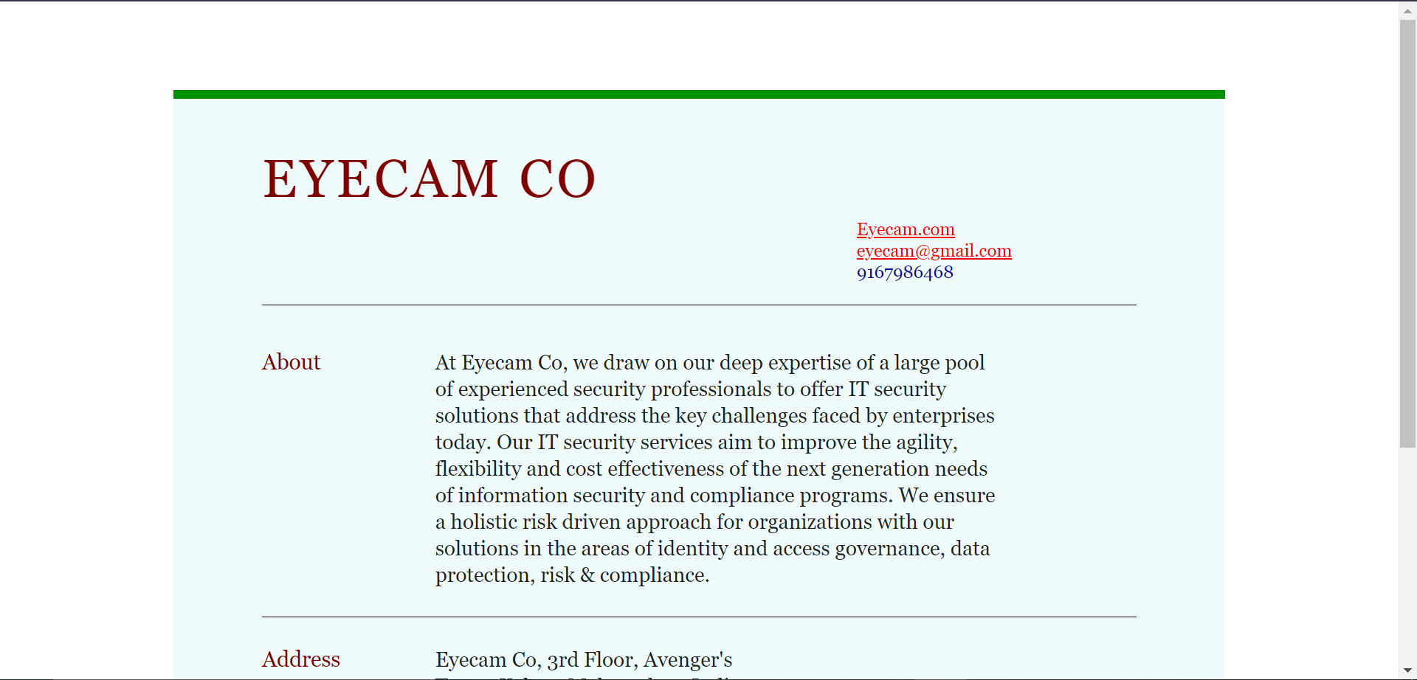

**Fig 5.12 Start-up Profile Page**

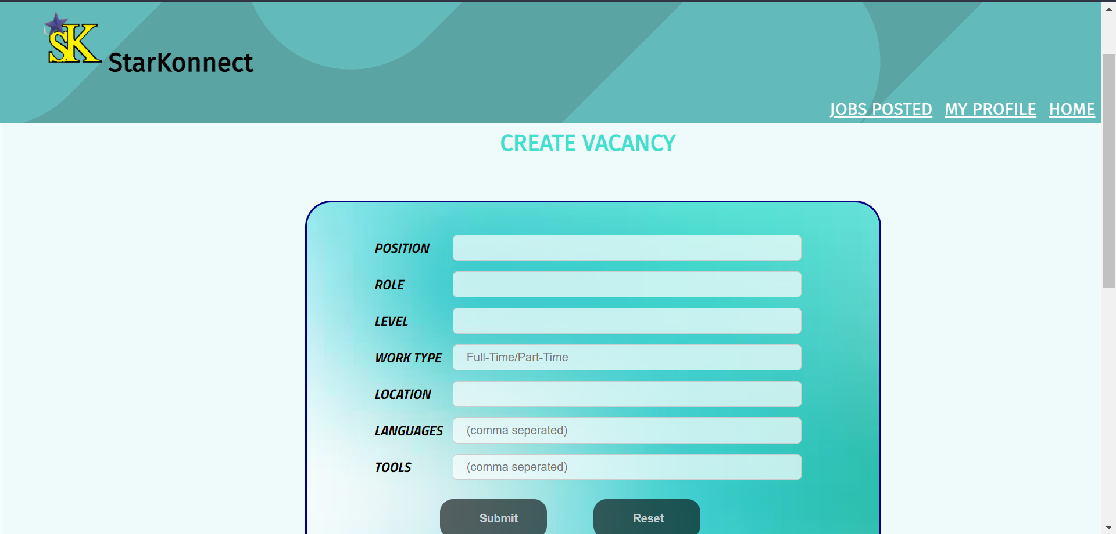

**Fig 5.13 Start-up Create Job Page**

**14**

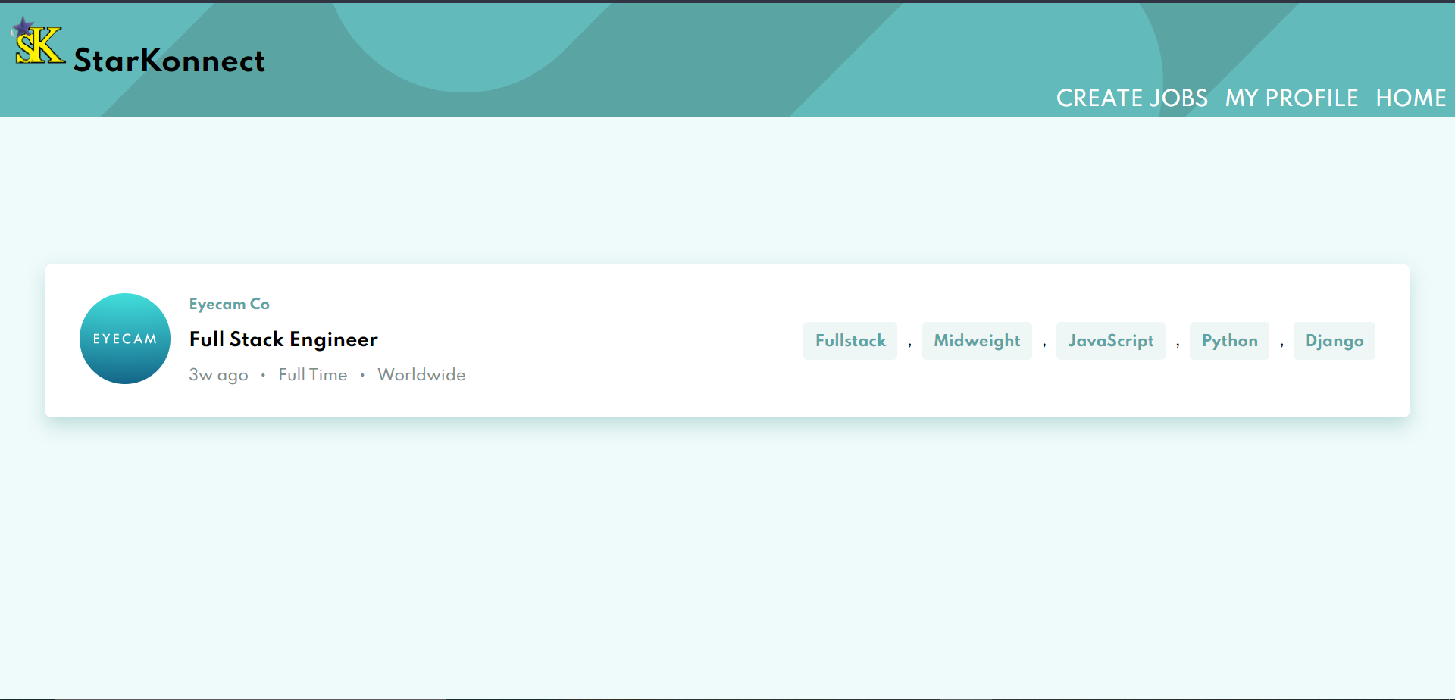

**Fig 5.14 Start-up Jobs Posted Page – Displays all the jobs created**

**5.2 Database Details**

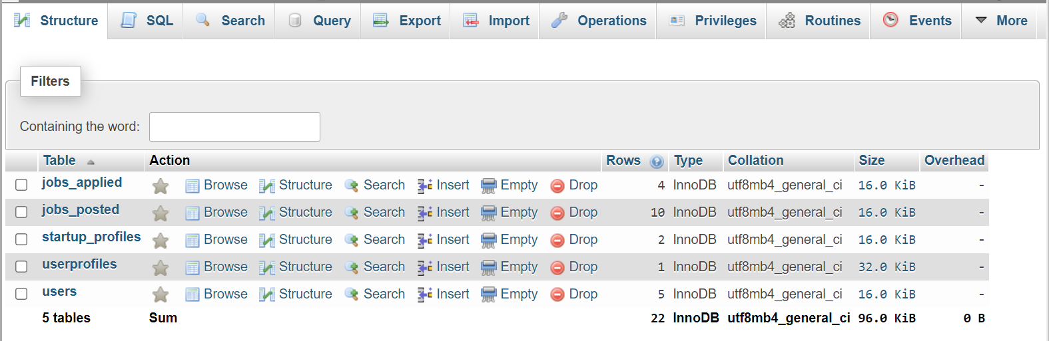

**5.21 Database Structure – The database contains 5 tables jobs_applied, jobs_posted, startup_profiles, userprofiles and users**

**15**

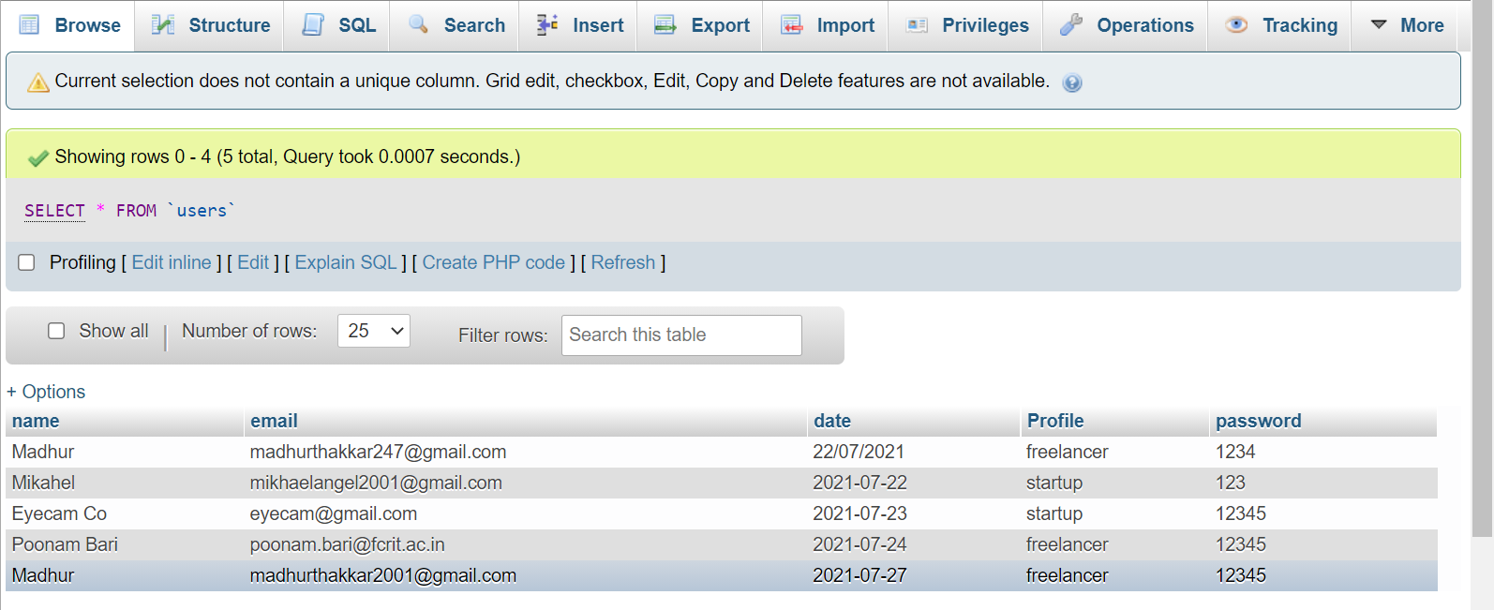

**5.22 users table – Contains data of all the users who are signed up. This data is used for logging in the user.**

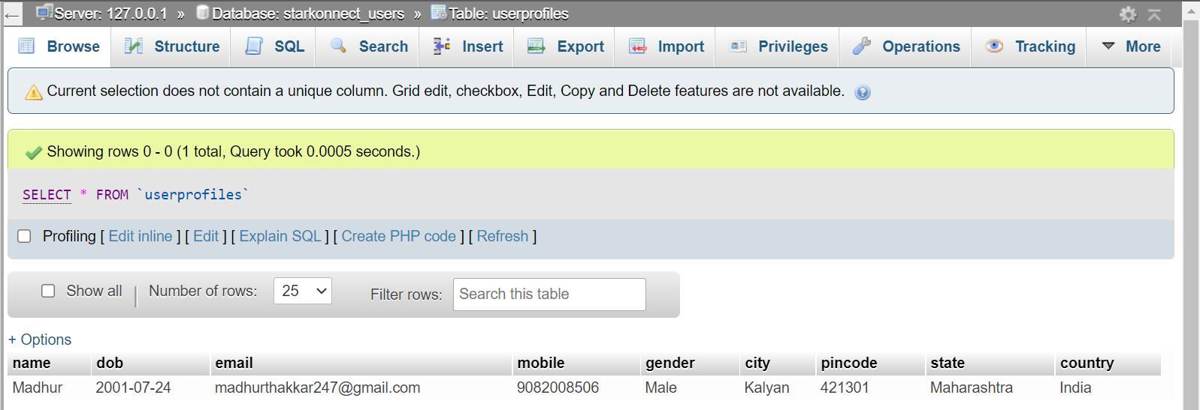

**5.23 usersprofiles table – Contains data of all the freelancers who have created their profiles. These details are visible in My Profile page.**

**16**

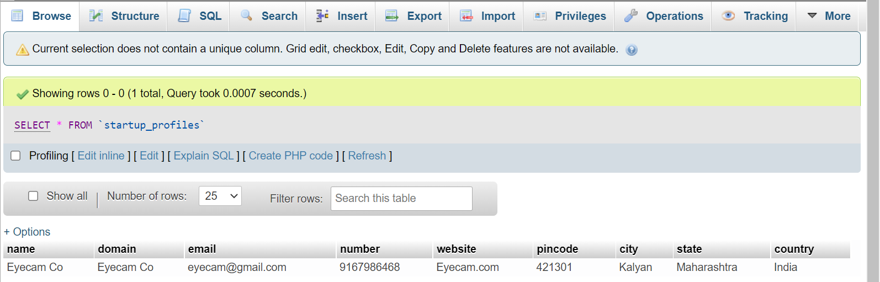

**5.24 startup_profiles table – Contains data of all the start-ups who have created their profiles. These details are visible in My Profile page**

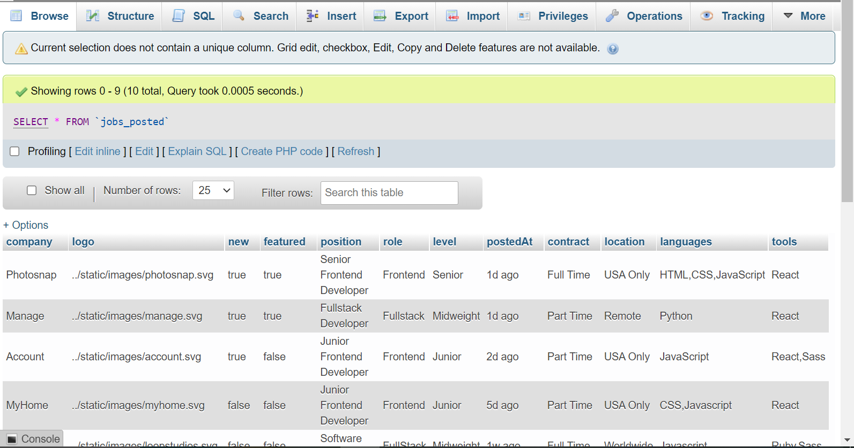

**5.25 jobs_posted table – Contains data of all the jobs that are created by the start-ups. These are visible to the freelancers for applying.**

**17**

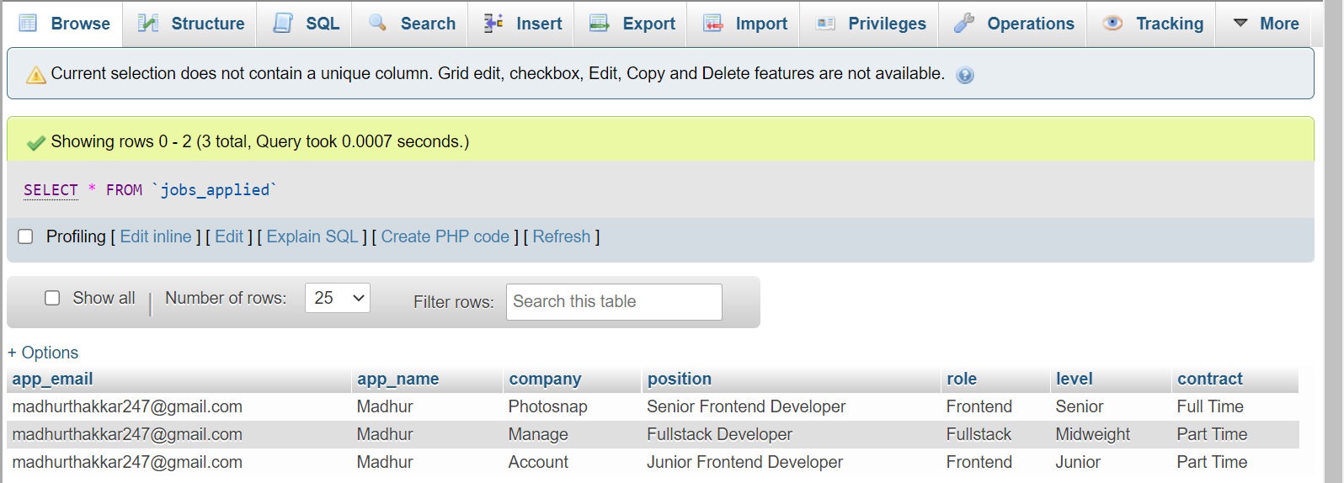

**5.26 jobs_applied table – Contains data of the jobs that are applied by the freelancers and the email ids of the freelancers who applied for them. These are visible to the freelancers in My Applications page.**

**18**

**CHAPTER 6**

**EXPERIMENTAL RESULTS**

**6. EXPERIMENTAL RESULTS**

We had aimed to design a website that will connect Start-ups and Freelancers so as to simplify recruitment process and help emerging start-ups to grow. We successfully developed a website using HTML5, CSS3, JavaScript and Flask Python framework to achieve our objective and have created an elegant User Interface to provide a smooth experience. The Login/Sign Up process is easy and interactive as well as secure. We have provided various features like My Applications so that Freelancers can keep track of the jobs they have applied to and a Create Jobs and Job Posted page for Start-ups to post and keep track of jobs easily, apart from common features like My Profile and all this in a manner that will not overwhelm the users.

**19**

**CHAPTER 7**

**CONCLUSION/FUTURE SCOPE**

**7 CONCLUSION/FUTURE SCOPE**

**7.1 CONCLUSION**

Job Search Portals stands as a revolutionizing element in the sphere of recruitment. They act as a communication bridge between applicants and recruiters facilitating their requirements.StartKonnect website helps organizations to have a greater exposure to the candidate pool and also job seekers facilitating wide search of jobs matching their interests. It provides flexibility to the jobseekers to view the openings and applied jobs. This website provides an enhanced user experience for both employer and jobseeker. It provides user friendly interface which facilitates in reaching wide range of audience. The application has achieved all the requirements that were initially set in the requirements gathering phase.

**7.2 FUTURE SCOPE**

1. Provide Encryption of password.
2. Perform Data Validation.
3. Provide Messaging feature.
4. Provide resume-builder
5. Create a search engine.

**20**

**CHAPTER 8**

**APPENDIX:CODE SAMPLES**

**8 APPENDIX: CODE SAMPLE**

from flask import *

from flask_mail import Mail, Message

import random

import secrets

from flask_mysqldb import MySQL

from flask_session import Session

from datetime import datetime

app = Flask(__name__)

app.config['MYSQL_HOST'] = 'localhost'

app.config['MYSQL_USER'] = 'root'

app.config['MYSQL_PASSWORD'] = ''

app.config['MYSQL_DB'] = 'starkonnect_users'

mysql = MySQL(app)

app.secret_key = secrets.token_bytes(16)

app.config['SESSION_PERMANENT'] = False

app.config['SESSION_TYPE'] = "filesystem"

Session(app)

app.config['MAIL_SERVER'] = 'smtp.gmail.com'

app.config['MAIL_PORT'] = 465

app.config['MAIL_USERNAME'] = 'startkonnect4@gmail.com'

app.config['MAIL_PASSWORD'] = 'startkonnect1234'

app.config['MAIL_USE-TLS'] = False

app.config['MAIL_USE_SSL'] = True

mail = Mail(app)

@app.route('/')

def index():

    return render_template("login.html")

@app.route('/verify', methods=['GET','POST'])

def verify():

    if request.method == "POST":

        if request.form['name']!="" and request.form['email']!="" and request.form['password']!="":

            ver_email = request.form['email']

**21**

 session['email'] = ver_email

            reg = None

            try:

                cur = mysql.connection.cursor()

                cur.execute("SELECT * FROM users WHERE email = '"+session.get('email')+"'")

                reg = cur.fetchone()

                print(reg,session.get('email'))

                mysql.connection.commit()

                cur.close()

            except:

                print(reg,session.get('email'))

            if reg is None:

                otp_gen = random.randint(100000,999999)

                session['otp'] = otp_gen

                print("verify")

                print(session.get('otp'))

                msg="Your One Time Password for Starkonnect is: "+str(session.get('otp'))

                message = Message("OTP Verification",sender="email",recipients=[session.get('email')])

                message.body = msg

                mail.send(message)

                success = "Message Sent"

                session['name'] = request.form.get('name')

                session['password'] = request.form['password']

                return render_template("otpverification.html",success=success)

            else:

                flash('This Email is already registered')

                return render_template("login.html")

        else:

            flash('Please enter all the details properly!')

            return render_template("login.html")

@app.route('/authenticate', methods=['GET','POST'])

def authenticate():

    if request.method == "POST":

        otp_enter = request.form['otp']

        if len(otp_enter)<1:

**22**

            otp_enter = -1

        if int(otp_enter)==session.get('otp'):

            return render_template("select.html")

        else:

            if otp_enter==-1:

                flash(u"New OTP is sent to {0}".format(session.get('email')))

            else:

                flash(u"Incorrect OTP\nTry Again!")

            return render_template("otpverification.html")

@app.route('/resend_verify', methods=['GET','POST'])

def resend_verify():

    if request.method == "POST":

        #email = request.form['email']

        otp_gen = random.randint(100000,999999)

        session['otp'] = otp_gen

        print("resend")

        print(session.get('otp'))

        msg="Your One Time Password for Starkonnect is: "+str(session.get('otp'))

        message = Message("OTP Verification",sender="startkonnect4@gmail.com",recipients=[session.get('email')])

        message.body = msg

        mail.send(message)

        success = "Message Sent"

        return render_template("otpverification.html",success=success)

@app.route('/selection',methods=['GET','POST'])

def selection():

    if request.method=='POST':

        chkbox = request.form.getlist('chkbox')

        session['profile'] = chkbox[0]

        cur = mysql.connection.cursor()

        cur.execute("INSERT INTO users VALUES('"+session.get('name')+"','"+session.get('email')+"','"+str(datetime.now())+"','"+session.get('profile')+"','"+session.get('password')+"')")

        mysql.connection.commit()

        cur.close()

        # cur = mysql.connection.cursor()

        # cur.execute("SELECT * FROM jobs_posted")

**23**

        # jobs = cur.fetchall()

        # mysql.connection.commit()

        # cur.close()

        # lis = list()

        # i=1

        # for ele in jobs:

        #     dic = dict()

        #     dic['id'] = i

        #     dic['company'] = ele[0]

        #     dic['logo'] = ele[1]

        #     dic['new'] = ele[2]

        #     dic['featured'] = ele[3]

        #     dic['position'] = ele[4]

        #     dic['role'] = ele[5]

        #     dic['level'] = ele[6]

        #     dic['postedAt'] = ele[7]

        #     dic['contract'] = ele[8]

        #     dic['location'] = ele[9]

        #     dic['languages'] = ele[10].split(',')

        #     dic['tools'] = ele[11].split(',')

        #     i+=1

        #     lis.append(dic)

        if session.get('profile')=="freelancer":

            return render_template("homepage.html")

        elif session.get('profile')=="startup":

            return render_template("homepage-startup.html")

@app.route('/userlogin',methods=['GET','POST'])

def userlogin():

    if request.method=='POST':

        if request.form['loginemail'] != "" and request.form['loginpass'] != "":

            email = request.form['loginemail']

            session['email'] = email

            session['password'] = request.form['loginpass']

            reg = None

            try:

                cur = mysql.connection.cursor()

                cur.execute("SELECT * FROM users WHERE email = '"+session.get('email')+"'")

                reg = cur.fetchone()

                session['name'] = reg[0]

                session['profile'] = reg[3]

                mysql.connection.commit()

                cur.close()

**24**

            except:

                pass

            if reg is None:

                flash('This Email is not registered')

                return render_template("login.html")

            else:

                jobs = ()

                if session.get('password')==reg[4]:

                #     cur = mysql.connection.cursor()

                #     cur.execute("SELECT * FROM jobs_posted")

                #     jobs = cur.fetchall()

                #     mysql.connection.commit()

                #     cur.close()

                #     lis = list()

                #     i=1

                #     for ele in jobs:

                #         dic = dict()

                #         dic['id'] = i

                #         dic['company'] = ele[0]

                #         dic['logo'] = ele[1]

                #         dic['new'] = ele[2]

                #         dic['featured'] = ele[3]

                #         dic['position'] = ele[4]

                #         dic['role'] = ele[5]

                #         dic['level'] = ele[6]

                #         dic['postedAt'] = ele[7]

                #         dic['contract'] = ele[8]

                #         dic['location'] = ele[9]

                #         dic['languages'] = ele[10].split(',')

                #         dic['tools'] = ele[11].split(',')

                #         i+=1

                #         lis.append(dic)

                    if session.get('profile')=="freelancer":

                        return render_template("homepage.html")

                    elif session.get('profile')=="startup":

                        return render_template("homepage-startup.html")

                else:

                    flash('Incorrect Password')

                    return render_template('login.html')

        else:

            flash('Please enter all the details properly!')

            return render_template("login.html")

@app.route('/myprofile',methods=['GET','POST'])

def myprofile():

**25**

    if request.method=="POST":

        profile = ""

        found = False

        try:

            cur = mysql.connection.cursor()

            cur.execute("SELECT Profile FROM users WHERE email = '"+session.get('email')+"'")

            profile = cur.fetchone()[0]

            mysql.connection.commit()

            cur.close()

        except:

            profile = ""

        try:

            cur = mysql.connection.cursor()

            if profile=="freelancer":

                cur.execute("SELECT name FROM userprofiles WHERE email = '"+session.get('email')+"'")

            elif profile=="startup":

                cur.execute("SELECT name FROM startup_profiles WHERE email = '"+session.get('email')+"'")

            if cur.fetchone()[0]:

                found = True

            mysql.connection.commit()

            cur.close()

        except:

             pass

        if profile=="freelancer":

            if found:

                return render_template("Freelancer-Profile.html")

            else:

                return render_template("Freelancer.html")

        elif profile=="startup":

            if found:

                return render_template("Startup-Profile.html")

            else:

                return render_template("Startup.html")

        print(profile)

@app.route('/viewprofile/<prof>',methods=['GET','POST'])

def viewprofile(prof):

    if request.method=="POST":

        if prof=="freelancer":

            session['dob'] = request.form['dob']

            session['mob'] = request.form['Mobile_Number']

            genbox = request.form.getlist('Gender')

**26**

            session['gender'] = genbox[0]

            session['city'] = request.form['city']

            session['pincode'] = request.form['pincode']

            session['state'] = request.form['State']

            session['country'] = request.form['Country']

            try:

                cur = mysql.connection.cursor()

                #print("INSERT INTO userprofiles VALUES('"+session.get('name')+"','"+session.get('dob')+"','"+session.get('email')+"','"+session.get("mob")+"','"+session.get('gender')+"','"+session.get('city')+"','"+session.get('pincode')+"','"+session.get('state')+"','"+session.get('country')+"')")

                cur.execute("INSERT INTO userprofiles VALUES('"+session.get('name')+"','"+session.get('dob')+"','"+session.get('email')+"','"+session.get("mob")+"','"+session.get('gender')+"','"+session.get('city')+"','"+session.get('pincode')+"','"+session.get('state')+"','"+session.get('country')+"')")

                mysql.connection.commit()

                cur.close()

            except Exception as e:

                print(e)

        elif prof=="startup":

            session['domain'] = request.form['Company_Domain']

            session['number'] = request.form['Contact_Number']

            session['website'] = request.form['Website']

            session['city'] = request.form['City']

            session['pincode'] = request.form['Pin_Code']

            session['state'] = request.form['State']

            session['country'] = request.form['Country']

            try:

                cur = mysql.connection.cursor()

                print("INSERT INTO startup_profiles VALUES('"+session.get('name')+"','"+session.get('domain')+"','"+session.get('email')+"','"+session.get("number")+"','"+session.get('website')+"','"+session.get('pincode')+"','"+session.get('city')+"','"+session.get('state')+"','"+session.get('country')+"')")

                cur.execute("INSERT INTO startup_profiles VALUES('"+session.get('name')+"','"+session.get('domain')+"','"+session.get('email')+"','"+session.get("number")+"','"+session.get('website')+"','"+session.get('pincode')+"','"+session.get('city')+"','"+session.get('state')+"','"+session.get('country')+"')")

                mysql.connection.commit()

                cur.close()

                print("Added")

            except Exception as e:

                print(e)

        if prof=="freelancer":

**27**

            return render_template("homepage.html")

        elif prof=="startup":

            return render_template("homepage-startup.html")

@app.route('/myapp',methods=['GET','POST'])

def myapp():

    if request.method=="POST":

        return render_template("Freelancer-Applications.html")

@app.route('/jobsposted',methods=['GET','POST'])

def jobsposted():

    if request.method=="POST":

        return render_template("Jobsposted.html")

@app.route('/Createjob',methods=['GET','POST'])

def Createjob():

    if request.method=="POST":

        return render_template("Create-Vacancy.html")

@app.route('/homebt/<profi>',methods=['GET','POST'])

def homebt(profi):

    if request.method=="POST":

        if profi=="freelancer":

            return render_template("homepage.html")

        elif profi=="startup":

            return render_template("homepage-startup.html")

@app.route('/applyjob/<company>',methods=['GET','POST'])

def applyjob(company):

    if request.method=="POST":

        cur = mysql.connection.cursor()

        cur.execute("SELECT * FROM jobs_posted WHERE company = '"+company+"'")

        jobcom = cur.fetchone()

        mysql.connection.commit()

        cur.execute("SELECT * FROM jobs_applied WHERE company = '"+company+"'")

        jobcheck = cur.fetchone()

        mysql.connection.commit()

        cur.close()

        if jobcheck:

            if jobcheck[0]==session.get('email') and jobcheck[2]==company and jobcheck[3]==jobcom[4]:

                flash("You have already applied for the position of "+jobcom[4]+" at "+company+" as "+jobcom[8])

                return render_template("homepage.html")

**28**

            else:

                cur = mysql.connection.cursor()

                cur.execute("INSERT INTO jobs_applied VALUES ('"+session.get('email')+"','"+session.get('name')+"','"+company+"','"+jobcom[4]+"','"+jobcom[5]+"','"+jobcom[6]+"','"+jobcom[8]+"')")

                mysql.connection.commit()

                cur.close()

                flash("You have successfully applied for the position of "+jobcom[4]+" at "+company+" as "+jobcom[8])

                return render_template("homepage.html")

        else:

            cur = mysql.connection.cursor()

            cur.execute("INSERT INTO jobs_applied VALUES ('"+session.get('email')+"','"+session.get('name')+"','"+company+"','"+jobcom[4]+"','"+jobcom[5]+"','"+jobcom[6]+"','"+jobcom[8]+"')")

            mysql.connection.commit()

            cur.close()

            flash("You have successfully applied for the position of "+jobcom[4]+" at "+company+" as "+jobcom[8])

            return render_template("homepage.html")

if __name__ == '__main__':

    app.run()

**29**

**CHAPTER 9**

**REFERENCES**

25

**9. REFERENCES**

These numbers should come in the report in the serial order in which they are being used. Any content from the internet needs to be references properly in the manner given below.

1. <https://www.linkedin.com/help>
2. https://internshala.com/about_us
3. https://www.monster.com/about/



**30**

**CHAPTER 10**

**ACKNOWLEDGEMENT**

**10 ACKNOWLEDGEMENT**

We would like to express our heartfelt gratitude to our college Fr. Conceicao Rodrigues Institute of Technology for giving us an opportunity to undertake this project. We are grateful to our H.O.D. Dhanashree Hadsul Mam for giving us a chance to work on this project in our course of Engineering. We are thankful to, and fortunate enough to get constant encouragement, support and guidance from all our teachers of IT Department which helped us in successfully completing our project.

We would also like to extend our gratitude to our parents for their support throughout, and the constant efforts and motivation by our teammates and friends which helped us attain successful completion of this project.

.

**31**